THe Housing Project App - Working

The app opens up with a screen that asks you to sign-in or sign-up

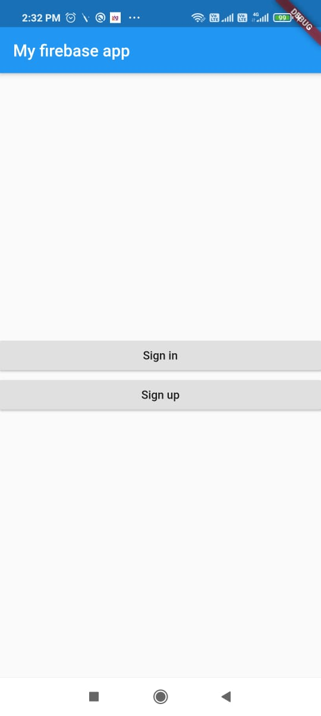

If you click Sign-in You will be taken to a login screen. When you enter the e-mail id and password. It is authentified and you would enter the homepage.

**Firebase is used for this Authentication**

( *If you click SIgn up, you would be asked to register using an email and password.*

***Firebase is used to store these data and later use it for authentication.***

*When you click Register. You would be taken to a form where you need to fill the data about your house.*

***These Data would be stored in the Firebase Database using FireStore*)**

The Screenshot of registration page is Given below

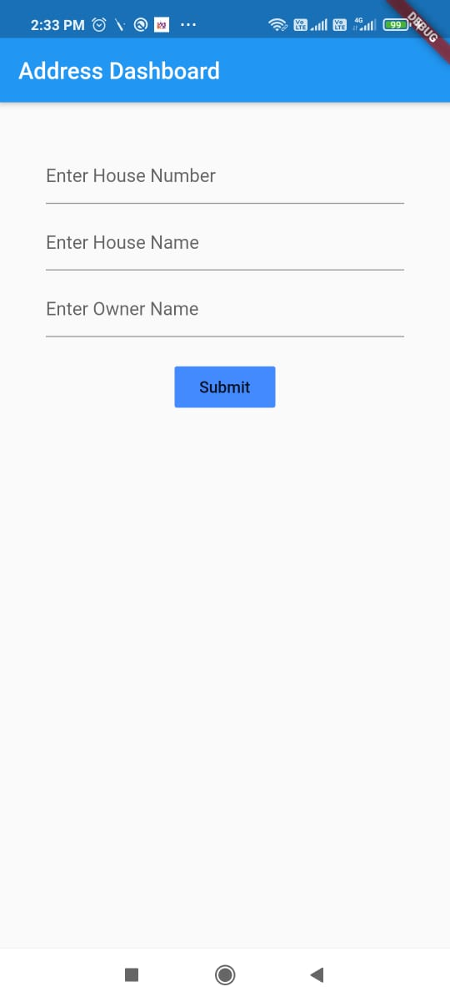

After clicking register you will reach homepage.

HOME PAGE

The sign in will directly take you to this homepage,The signup will take you to homepage after registration.

Image of HomePage given below:

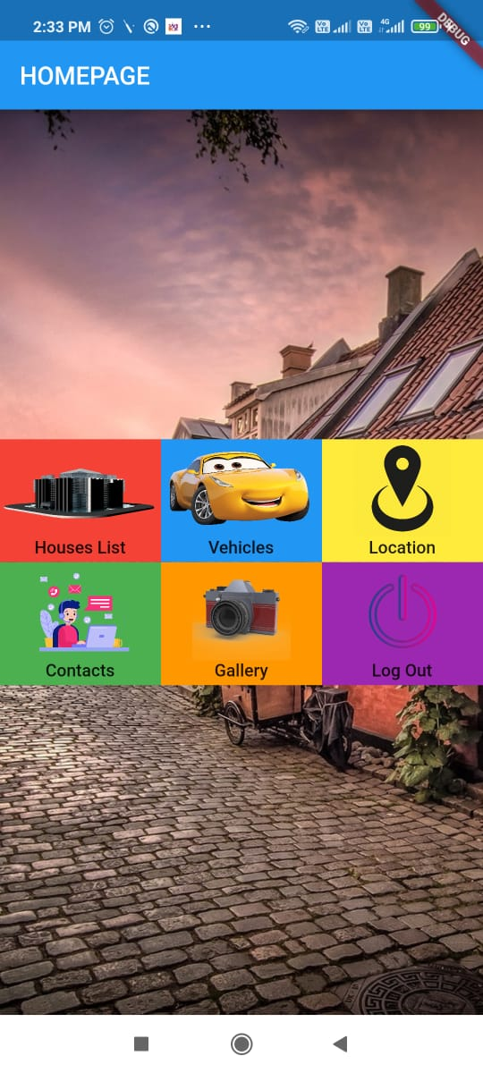

There are 6 options provided: They are

1. House List

**Retrieves the list of all houses from Firebase Database.**

It shows all the house names and owner names in the database

The image of list is shown below

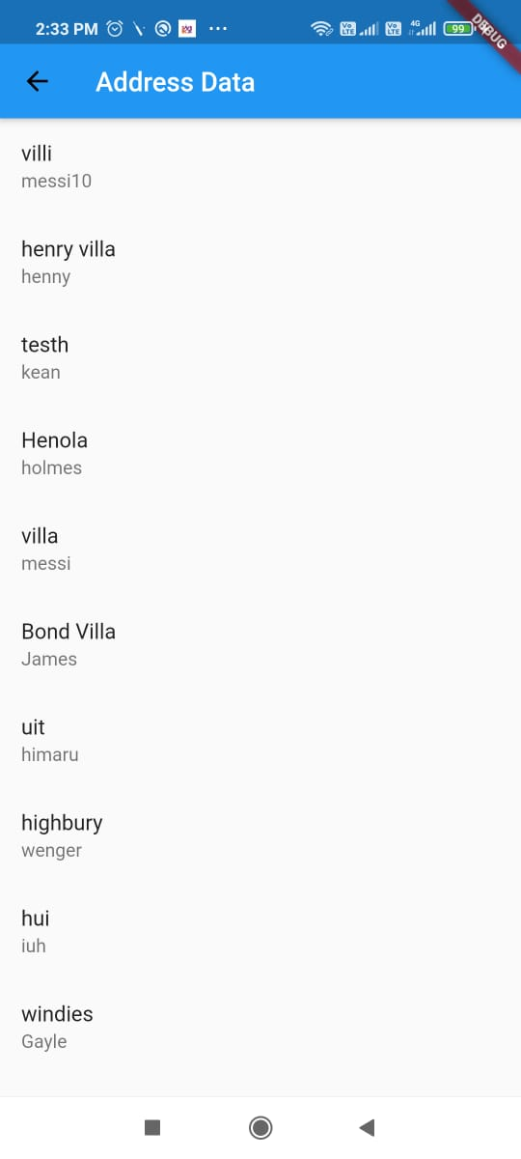

2.Vehicles

Shows the list of all vehicles using a **local database created using Sqlite to maintain persistence**

**Tapping on an element would help to update the data and the delete button would erase the data**

The image is shown below

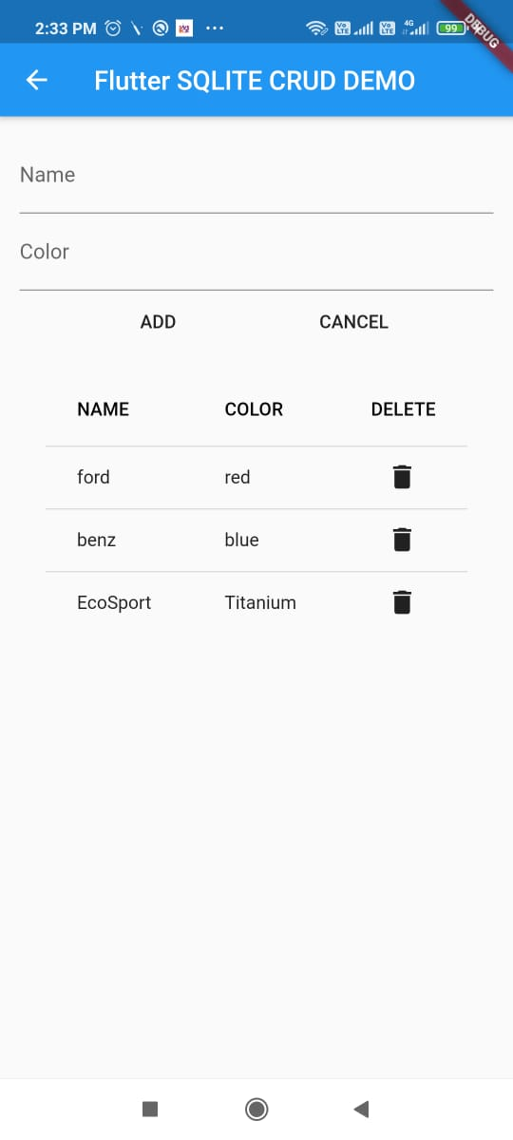

**3.Location**

Taping on location would take you to a window with a button that asks to launch the map.

The location is currently set to Wonderpark in Mumbai

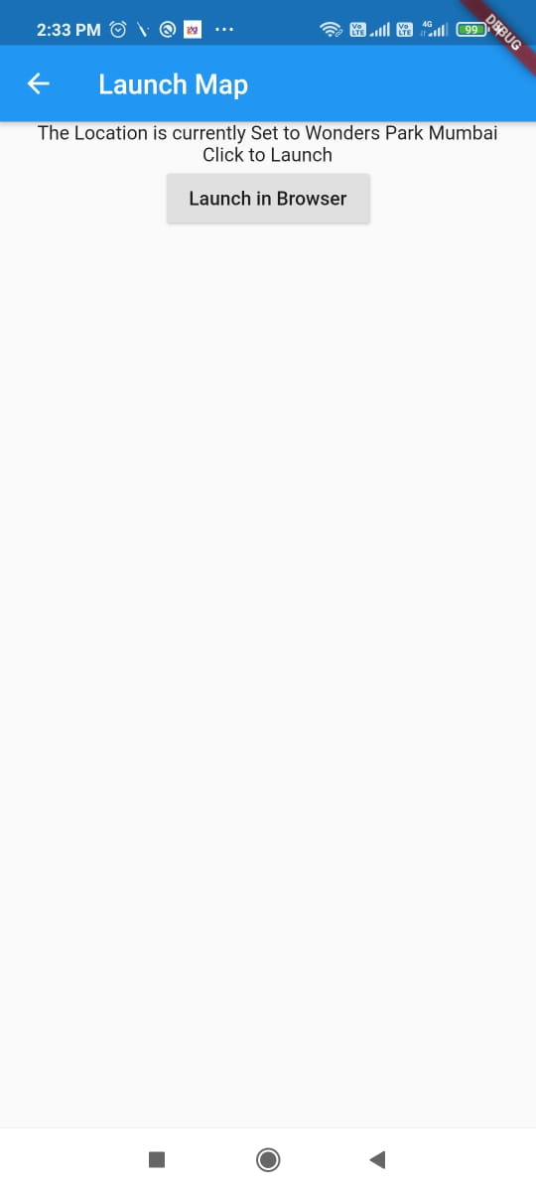

When you click the button the google maps app or website opens with a pointer on the preset location.(Wonderpark Mumbai)

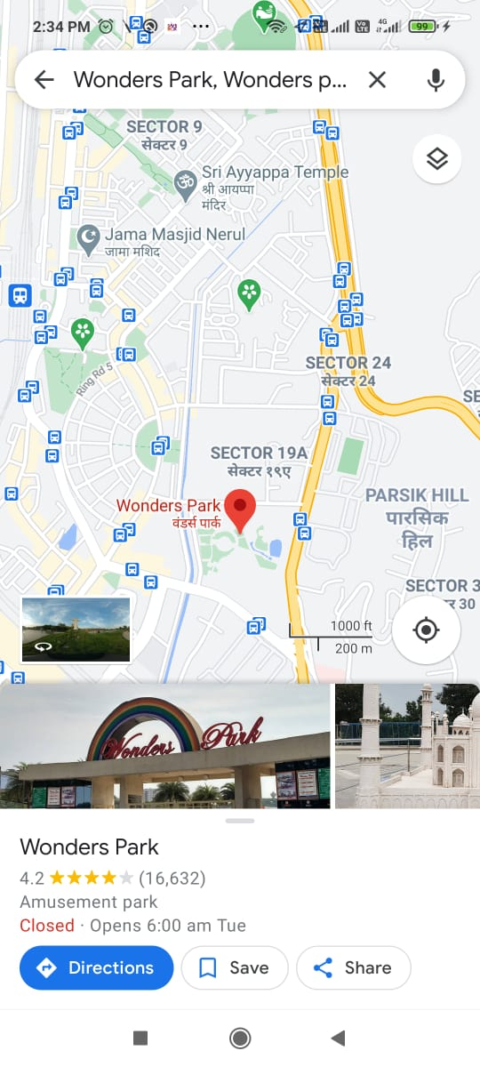

**4.Contacts**

Clicking on Contacts will open up a window that shows the Address of the apartment,neaby hospital and police station

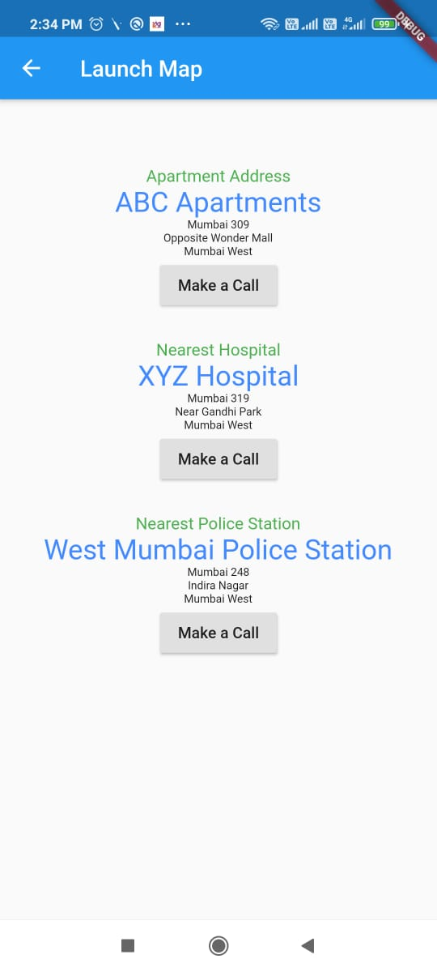

**Tapping the make a call button would automatically take you to your dialler with the number already typed**

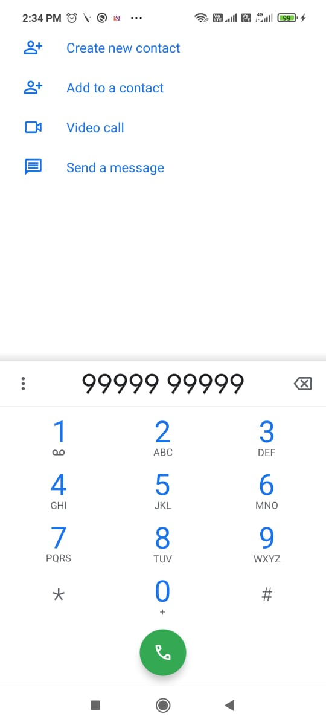

**GET-IT**

**The State Management approach get-it is used in this app.**

**It is used in the instances:**

* **When the map is loaded in Locator**
* **When the dialler is opened with the preset Number in Contacts**

**5.Gallery**

Tap on Gallery opens up an Image Gallery with the images of different parts of the housing project

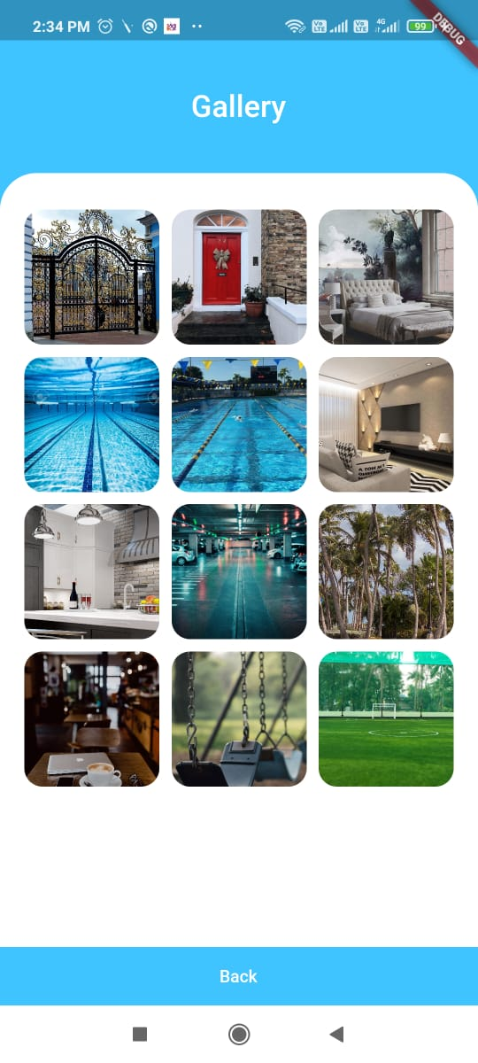

Clicking On one of the images will enlarge the image for better view

**6.LogOut**

Pressing Log out takes you back to the Sign-In/Sign up Window